**Experiment Title 3**

**Student Name: Husanpreet Kaur UID: 20BCS9512**

**Branch: BE-CSE Section/Group: 20BCS-DM-714/A**

**Semester: 6 Subject Code: 20CSP-376**

**Subject Name: Data Mining Lab Date of Performance: 09-03-2023**

1. **Aim/Overview of the practical:** Demonstration of association rule mining using Apr.
2. **Tools used:** RStudio and RWeka
3. **Code:**

library(arules)

library(arulesViz)

library(RColorBrewer)

data("Groceries")

rules <- apriori(Groceries, parameter = list(supp = 0.01, conf = 0.2))

inspect(rules[1:10])

arules::itemFrequencyPlot(Groceries, topN = 20,col = brewer.pal(8, 'Pastel2'),main = 'Relative Item Frequency Plot',type = "relative",ylab = "Item Frequency (Relative)")

1. **Output:**

RStudio:

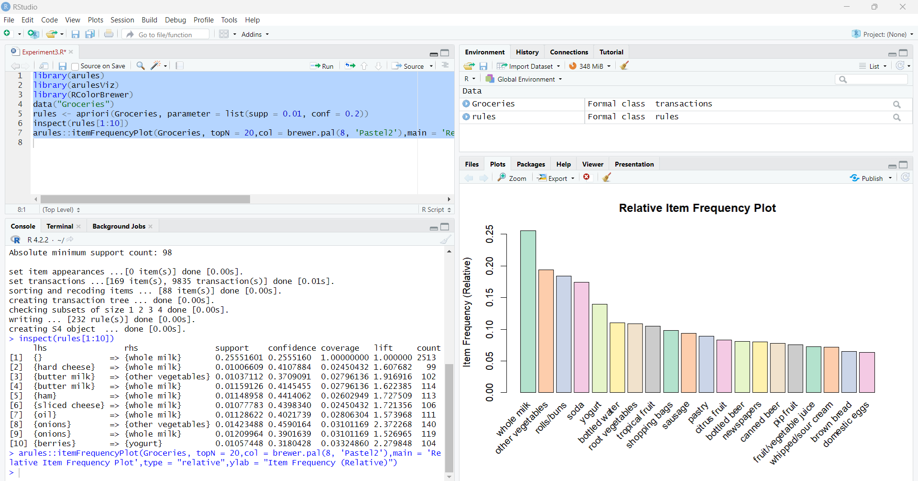

1. **Observation:**

* Learnt how to use R and create a file in Rstudio.
* Learnt how to install packages in Rstudio.
* Learnt about drawing of plots.